Texture Segmentation

Intent -

The program takes an image with different clusters, pixels sharing features such as color, intensity, or texture, and identifies each one. Can be used to detect targets in an image.

**Arguments-**

Below are the arguments for the program. The arguments in bold are mandatory. The other arguments will set a default if not provided, however it will make the program more accurate if they are provided.

* **File of the image**
* **File of the output image**
* **Number of clusters**
* **Size of Gabor kernel**
* **Size of the gaussian window**
* Spatial weight of the row and columns for clustering, DEFAULT = 1
* Spatial aspect ratio, DEFAULT = 1
* Spread of the filter, DEFAULT = 1
* Offset phase, DEFAULT = 0
* Variance Threshold, DEFAULT = 0.0001
* Maximum number of feature images wanted, DEFAULT = 100
* Energy R threshold, DEFAULT = 0.95
* Sigma weight for gaussian smoothing, DEFAULT = 0.5
* Output grey? True/False, DEFAULT = False
* Print intermediate results (filtered/feature images)?True/False, DEFAULT = False

The program was tested with the following image below and it was able to find the different textures well. The increase in accuracy can be seen clearly when more inputs are given.

Image - 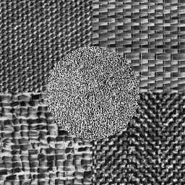

1. Input : Clusters - 5, Size of Gabor Kernel - 17, Size of Gaussian Window - 31

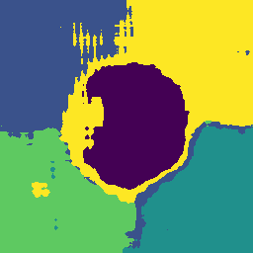

1. Input : Clusters - 5, Size of Gabor Kernel - 17 , Size of Gaussian Window - 31, sigma - 7



1. Input : Clusters - 5, Size of Gabor Kernel - 17 , Size of Gaussian Window - 31, sigma - 7, spatial weight of rows and columns - 2

